

SUPER MART T-SQL CAPSTONE PROJECT

Developer: MARTIN KAMOGELO SHAI
Date: 2026
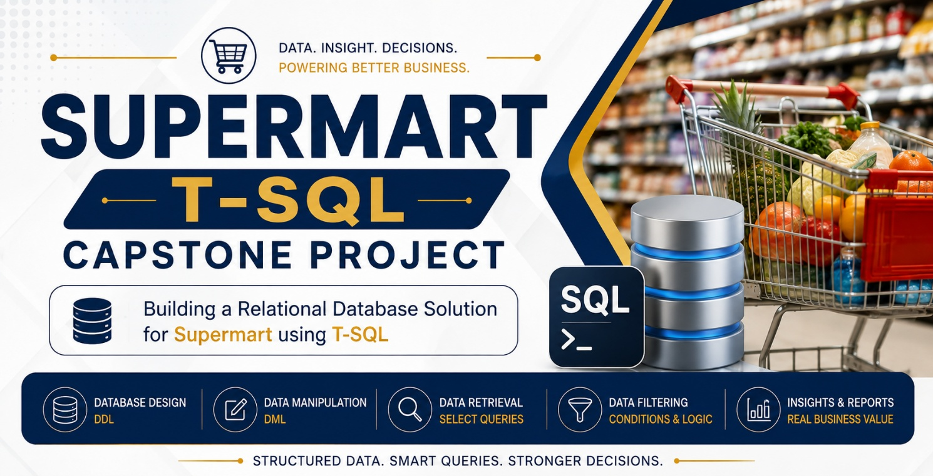

SuperMart T-SQL Capstone Project
Case Study Background
SuperMart is a growing retail business that specializes in providing everyday grocery and household products to customers across South Africa. As part of its expansion strategy, the company is preparing to open a new branch in Johannesburg. The new branch is expected to attract customers from Johannesburg, Pretoria, Cape Town, and surrounding areas, resulting in an increase in customer registrations, sales transactions, and order activity.
Currently, SuperMart's management requires a structured database solution that can store and manage important customer and order information. Without a properly designed database, information such as customer details, telephone numbers, order dates, order statuses, and transaction amounts can become difficult to manage, retrieve, and analyse. Management also needs reliable reports to support the Sales, Marketing, Finance, Operations, and Customer Relations departments.
To address this requirement, SuperMart has appointed a Junior Database Developer to design and implement a small relational database using Microsoft SQL Server and Transact-SQL (T-SQL). The proposed solution, known as SuperMart_Db, will provide a structured environment for storing customer and order information while demonstrating fundamental and advanced T-SQL capabilities.
The database will consist primarily of two related entities: Customers and Orders. The Customers table will store information such as customer identification numbers, names, location, telephone numbers, and email addresses. The Orders table will record customer orders, including order identification numbers, order dates, order statuses, and total transaction amounts. A primary key and foreign key relationship will be established to maintain data integrity between the two tables.
The capstone project simulates a realistic business environment in which database developers must not only create tables but also manipulate, retrieve, analyse, and protect business data. Sample customer and order records will be inserted into the database to represent SuperMart's operational environment. The dataset will include customers from different South African cities, different order dates throughout 2026, different order amounts and order statuses, missing telephone numbers, and customers who have not yet placed orders.
Once the database has been populated, different departments will use SQL queries to obtain useful business information. For example, the Sales Manager may require a report showing customer orders and transaction values, while the Marketing Manager may want to identify customers located in Gauteng. The Customer Relations department may need to identify customers who have not placed any orders, and the Finance department may require summaries showing average, highest, and lowest order values.
The project therefore requires the developer to apply a range of T-SQL techniques, including DDL, DML, SELECT statements, filtering, aliases, string manipulation, COALESCE(), joins, sorting, grouping, aggregate functions, date functions, subqueries, views, Common Table Expressions (CTEs), and stored procedures. Advanced database programming concepts such as IF...ELSE logic, transactions, and TRY...CATCH error handling will also be incorporated to demonstrate the ability to develop more reliable and maintainable database solutions.
Business Problem
SuperMart needs a centralized and structured database for managing customer and order information at its new Johannesburg branch. The business requires accurate information that can be retrieved quickly and transformed into meaningful reports for decision-making.
Without a properly designed database, SuperMart could experience problems such as:
- Duplicate or inconsistent customer information.
- Difficulty identifying customers who have placed orders.
- Difficulty identifying customers who have never placed an order.
- Challenges tracking order dates and order statuses.
- Limited ability to analyse sales performance.
- Difficulty generating reports for different departments.
- Increased risk of data integrity problems.
- Manual and repetitive database operations.
- Poor handling of database errors and failed transactions.
The proposed T-SQL database solution addresses these challenges by providing a relational structure in which customer and order information can be stored, linked, queried, and analysed efficiently.
Purpose of the Capstone Project
The purpose of the SuperMart T-SQL Capstone Project is to provide a practical business scenario in which students can demonstrate their ability to apply T-SQL concepts to a real-world database development problem.
Rather than learning SQL commands in isolation, students are required to use T-SQL to build a complete small-scale database solution from the ground up. This includes creating the database, designing tables, defining relationships, inserting sample data, retrieving information, generating reports, and implementing reusable database objects.
Project Objectives
The main objectives of the project are to:
- Create a functional SuperMart_Db database.
- Design Customers and Orders tables using appropriate data types.
- Implement primary keys and foreign key relationships.
- Populate the database with realistic sample data.
- Retrieve customer and order information using SELECT queries.
- Apply filtering and searching techniques to business data.
- Demonstrate INNER, LEFT, RIGHT, and FULL OUTER JOIN operations.
- Use sorting, grouping, and aggregate functions to analyse data.
- Apply SQL date and string functions to business information.
- Demonstrate the use of subqueries.
- Create a reusable database view.
- Create a Common Table Expression for customer order analysis.
- Develop and execute a stored procedure.
- Apply conditional logic using IF...ELSE.
- Implement transactions to maintain data consistency.
- Handle errors using TRY...CATCH.
- Produce meaningful reports that can support business decision-making.
Expected Business Value
The completed database solution will provide SuperMart with a foundation for managing customer and order information in a structured manner. The queries and reports developed during the project can help management understand customer distribution, order activity, customer purchasing behaviour, and transaction performance.
For example, management can use the database to identify customers with orders, determine customers without orders, analyse order values, review quarterly sales activity, and generate customer directories. These insights can support marketing campaigns, customer service activities, operational planning, and financial analysis.

============================================================
ACTIVITY 1 – CREATE DATABASE
============================================================

Database creation
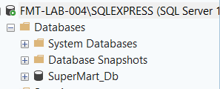

Table Creation
--- Customers Table Creation
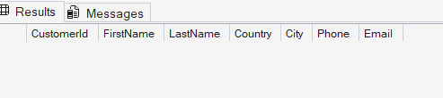

--- Orders Table Creation
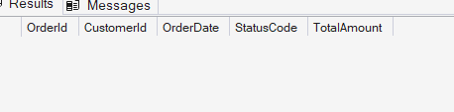
============================================================
ACTIVITY 2 – POPULATE DATABASE
============================================================

Sample data insertion
--- Customer table is inserted with data
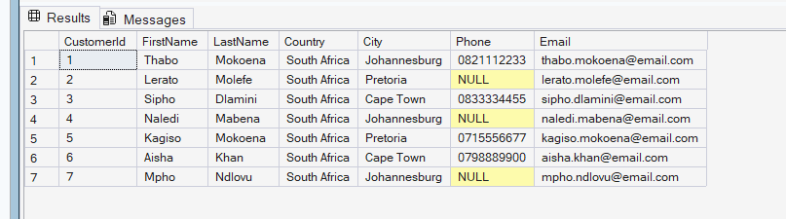
--- Order table is inserted with data
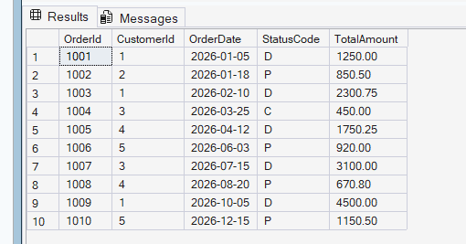

============================================================
ACTIVITY 3 – BASIC DATA RETRIEVAL
============================================================

All SQL queries
Query 1 - Customer Contact Report
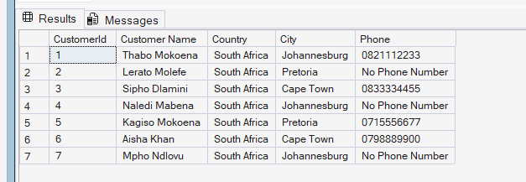

Query 2 - Customers from Gauteng Using IN operator
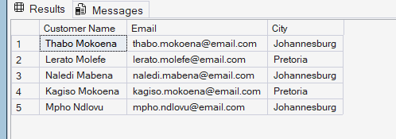
Query 3 - ORDERS DURING FIRST QUARTER OF 2026 Using BETWEEN
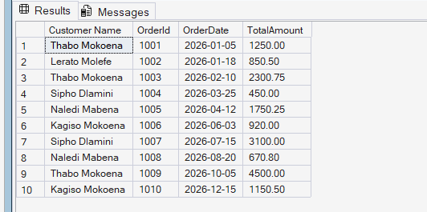

Query 4 - INNER JOIN….. Customers who have placed orders


Query 5 - LEFT JOIN - All customers including customers with no orders
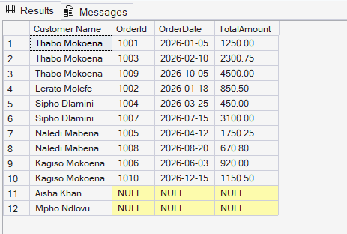

Query 6 - RIGHT JOIN - Every order including unmatched orders
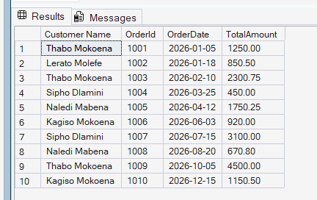

Query 7 - FULL OUTER JOIN - All customers and all orders
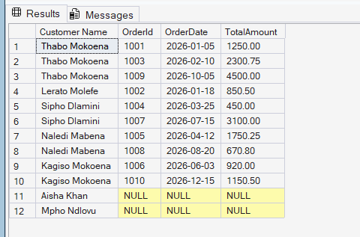

Query 8
Customer directory, UPPERCASE customer name, LENGTH OF FIRST NAME, Sort by FirstName ASC
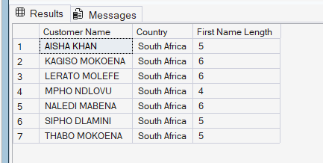

Query 9
Customer distribution by country
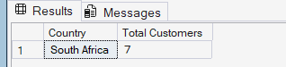

Query 10
Order summary
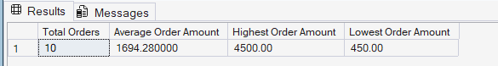

Query 11
The Operations Manager wants to review order activity
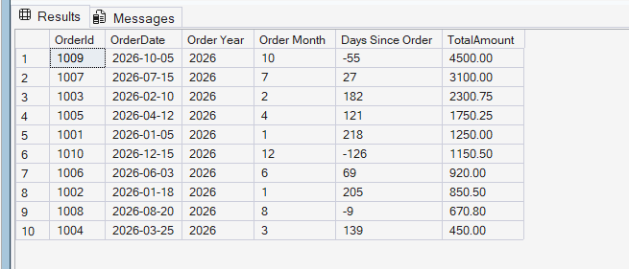

Query 12
SUBQUERY Customers who have placed at least one order


Query 13
SECOND SUBQUERY Using EXISTS
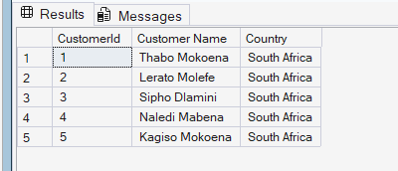

View
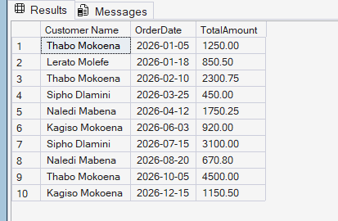

Extension
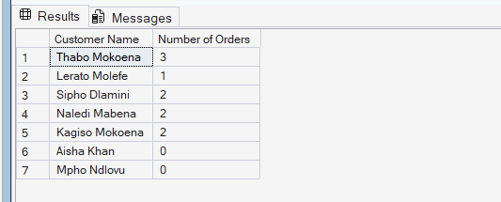

Stored procedures
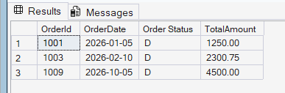

Transactions
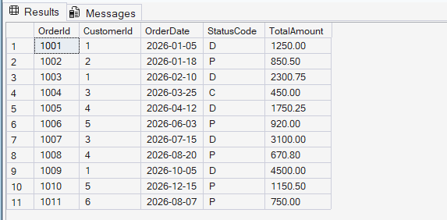

Error handling
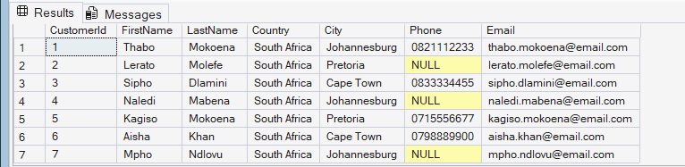

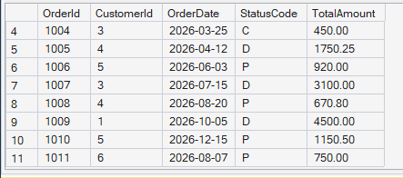

Conclusion
The SuperMart T-SQL Capstone Project represents a realistic database development scenario in which technical SQL knowledge is applied to solve practical business problems. By developing the SuperMart_Db database, students demonstrate their ability to move from database design and data manipulation to advanced querying, reporting, automation, and error handling.
The project ultimately demonstrates how T-SQL can transform raw customer and order data into structured business information that supports better decisions. It provides students with practical experience that can be applied to future database development, data analysis, business intelligence, and software development projects.

